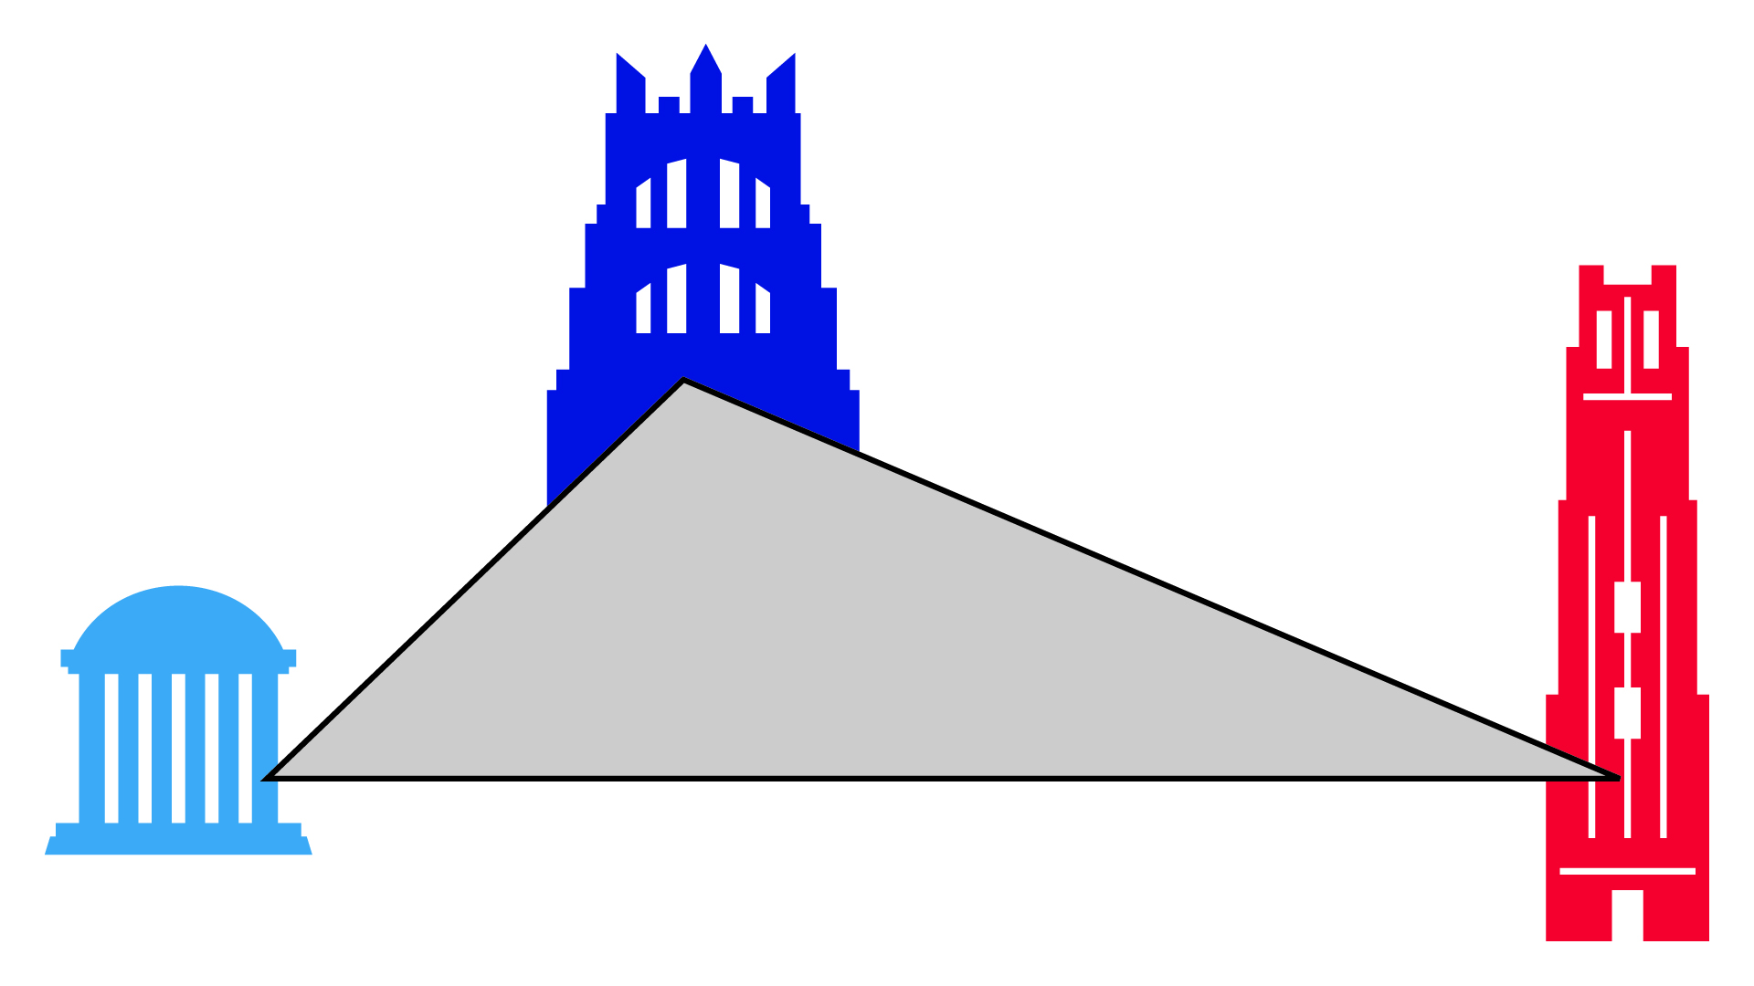

**Tenth Annual New Faces Conference**

**Speaker Abstracts**

**Paul Chamberlin, History, The Ohio State University and Yale University, “Preparing for Dawn: The United States and the Global Politics of Palestinian Resistance.”**

Using research from the Middle East, the United States, the United Kingdom, this dissertation examines the international history of the Palestinian armed struggle from late 1967 until the beginning of the Lebanese Civil war in 1975. Based on multi-archival and multilingual research in Lebanon, the United States, and the United Kingdom, I argue that the Palestinian guerillas won the struggle for international recognition by identifying themselves with the cultural forces of anti-colonialism and Third World internationalism. By laying claim to the status of a national liberation struggle, Palestinian fighters tapped into networks of global support emanating from places like Beijing, Hanoi, Algiers, and Havana that allowed them to achieve a measure of political legitimacy in the international community and provided for the continued survival of their movement. At the same time, these efforts to emulate revolutionary movements from other parts of the world helped to reshape Palestinian national identity into a profoundly cosmopolitan organism; a product of 20th Century globalization. However, these radical visions of national liberation ran headlong into U.S. designs for global order; if radical Palestinians could create a “second Vietnam” in the Middle East, the implications for U.S. authority in the Third World could be disastrous. Through support for regional police powers like Israel and Jordan, Washington was able to mount a sustained counterinsurgency campaign that prevented a guerilla victory.   
  
**Amber Diaz, Duke University, Political Science, “Bumbling, Bluffing, and Bald-Faced Lies: Mis-Leading and Domestic Audience Costs in International Relations.”**  
  
In a democratic society, does the public seek transparency in the foreign policy-making process, or does it only seek successful outcomes? Do electorates hold leaders accountable for the perceived truthfulness of foreign policy claims or do they only evaluate whether the policies were successful? The existing literature on public opinion and foreign policy calls the accountability role for the public “audience costs,” and specifies that concerns about audience costs constrain leaders. But the literature is not clear on what sorts of foreign policy actions incur the most audience costs and in particular whether publics are prone to hold leaders accountable for statements that fall short of the truth. This gap in the literature is notable because so much of the debate surrounding significant policy issues is couched in retrospective, normative, moralizing language. These debates make no sense if the pragmatic, forward-looking dimensions of audience costs – reliability and success – are all that exist. Rather, as I will show through a set of experiments and historical case studies, there is a complex dynamic at work between the public's desire for successful outcomes and the high value placed upon truth-telling and transparency within a democracy. Studying cases of war justifications, I argue that the public will be motivated to punish leaders perceived as deceptive, but that the severity of audience costs imposed will be affected by factors including partisanship, degree of elite unity, and the leader's response to threatened punishments.

**Cale D. Horne, Political Science, The University of Georgia-Athens, “The Structure and Significance of Public Opinion in Non-Democratic Contexts.”**

This project addresses two direct but to-date unexamined questions: Do domestic audiences in non-democratic contexts develop preferences for their nation’s foreign and security policies? If so, how and to what extent can these preferences influence policymaking in settings where governments are not directly or obviously accountable to citizens? Scholarship on public opinion and government policy focuses on the determinants of the public’s policy preferences and, related, the relationship between these preferences and government policymaking. Both areas of inquiry, however, have been confined to democratic and Western contexts without exception. The relationship between opinion and policy in non-democratic contexts, where public opinion is deemed to matter less (if at all) and opinion data are scarce, is unexplored. By examining an array of policy issues across time in Iran, the Russian Federation, and the Palestinian Territories, this study is a first effort to fill this lacuna in opinion-policy research and, in so doing, provides new insights into the opaque world of autocratic politics. This study offers one response to opinion and policy scholar Paul Burstein’s (2003) call for the study of public opinion and government policy to be tested for greater generalizability, both geographically and in terms of policy areas. Indeed, this study goes one step further, testing the generalizability of existing findings beyond the context of the democratic state. More broadly, this study explores the internal dynamics of autocratic politics, which will generate new insights for how Western and democratic decision makers engage potential rivals. Understanding autocratic decision-making, and the constrained choice sets autocratic states may face as a result of domestic politics, can help leaders avoid conflicts that may result from a mutual misperception of intent.

**Nori Katagiri, Political Science, The University of Pennsylvania,“Evolving to Win: Sequencing Theory of Extra-Systemic Warfare.”**

The central puzzle of my dissertation is how non-state actors – guerrillas, insurgents, and terrorists broadly defined – fight and defeat foreign states in war. To solve this puzzle I use what I call the sequencing theory. It views war between state and non-state actors, or extra-systemic war, to evolve over time and looks at the nature of sequence as the key to explain variation in war outcomes. I argue that chances of victory for non-state actors depend on what sequences they take in prosecuting war. I substantiate this argument by analyzing 79 extra-systemic wars fought between 1816 and 1994. Historical research offers four findings; (1) non-state actors have lost 80% of all extra-systemic wars but have won 70% in the last 60 years, (2) modern extra-systemic wars are evolutionary and consequently successful, (3) there are five types of sequences in extra-systemic war: (A) conventional model, (B) primitive model, (C) degenerative model, (D) complex Maoist model, and (E) progressive model, and (4) Maoist and progressive models are responsible for this evolution. The reason why the Maoist and progressive models are successful is because they combine three phases– guerrilla warfare, conventional warfare, and political development – in sequential fashion. This research’s policy implication for the United States is that in order to win in Afghanistan and Iraq, it must prevent its adversaries from performing well in all these three stages by adopting a sequential approach I promote in my dissertation.

**Julia Osman, History, University of North Carolina at Chapel Hill, “The Citizen Army of Old Regime France.”**

This dissertation probes deeply into the origins of the French Revolution with an emphasis on military change and the long-term development of the French citizen army. It is no coincidence that in the years prior to the French Revolution, the French army underwent a time of confusion, soul-searching, and drastic change, rethinking the entire military structure and the philosophy behind it. This change began during the Seven Years’ War (1754-1763), when the French army had to contend with militaries of different cultures, both as enemies and as allies, in North America. The loss of this war opened the French army, and the French reading public, to different possibilities of military organization. These possibilities were further compounded by the French army’s brief foray into, and wide interest in, the American Revolution, which presented a victorious example of citizen warfare, reminding France of the universally admired ancient Greeks and Romans. The resulting changes in the French army reflected these influences, and while these reforms made the French army more effective, they also challenged the political and social status quo. As a result, French officers began thinking of soldiers as citizens, and French citizens became comfortable with the idea of being soldiers. The combined efforts of soldiers and citizens to pull down the Bastille in 1789 succeeded in arming citizens and igniting a Revolution. In addition to contributing to the historiographies of the Seven Years’ War, military reform, and the American Revolution, this dissertation shows how the military is often at the forefront of social change. More than a mere extension of political aims, war and the military that wages it has a profound effect on a nation’s character, society, and culture.

**T. Negeen Pegahi, Political Science, University of Chicago and Harvard, “Dangerous Deterrent? The Strategic Consequences of Nuclear Acquisition.”**

What is the effect of nuclear proliferation on the amount and type of conflict in the international system? Answering this question requires determining not only how the spread of nuclear weapons affects the likelihood of states to initiate conflict against nuclear powers, but also how the acquisition of nuclear weapons affects the likelihood of new nuclear states themselves initiating conflicts. While the former issue has received extensive treatment in the literature, work on the latter has only recently emerged. Without a logically-sound and historically-supported theory about the strategic consequences of nuclear acquisition, we cannot answer the broader question of what effect nuclear proliferation has on the amount and type of conflict in the world. Existing work holds that acquisition automatically emboldens weak, revisionist states to engage in greater amounts of lower-level conflict against their stronger, nuclear-armed adversaries. Acquisition does this by removing the adversary’s ability to credibly threaten to launch a full-scale conventional attack, as doing so now carries the risk of inviting nuclear use. Acquisition by such states therefore constrains their adversaries’ conventional coercive strategies, thereby providing these proliferators with a way around their relative weakness. Such logic also suggests an offensive motivation for why such states might seek nuclear weapons. I challenge the existing works' assumption that a stronger state needs or wants to rely on the threat of full-scale conventional attack to coerce a weaker one regarding the latter’s behavior at lower levels. Using a simple game-theoretic model, I find that the strong state is likely to prefer such a strategy under only the rarest conditions. I test my model against the universe of relevant dyadic cases (China vs. the Soviet Union, India vs. China, and Pakistan vs. India) as well as against a sample of extended coercion cases (China vs. the United States over Taiwan, and North Korea vs. the United States over South Korea). Showing that the model’s predictions are borne out in these as well allows me to make predictions about what nuclear acquisition could, and could not, do for weak, revisionist potential proliferators such as Iran.

**Paul Staniland, Political Science, MIT, “ Explaining Cohesion, Fragmentation, and Control in Insurgent Groups.”**

My dissertation studies the level and nature of control and cohesion in insurgent groups. I argue that cohesion and fragmentation are caused by the interaction of two variables – the structure of the social base upon which an organization mobilizes, and the presence or absence of external material support. I test this theory using within-conflict comparisons of twenty-four armed groups in Kashmir (1984-2005), Northern Ireland (1962-2005), and Sri Lanka (1972-2008). Research in India and Indian Kashmir, Northern Ireland, and Sri Lanka has allowed me to reconstruct the trajectories of groups in these conflicts using a combination of original historical research and focused comparisons. On the basis of approximately a year of fieldwork in Indian and Indian Kashmir, Northern Ireland, and Sri Lanka, involving interviews, archival research, and secondary sources in English and Urdu, I offer a theory arguing that the interaction of two variables determines patterns of cohesion and fragmentation. First, I argue that groups based on robust preexisting social ties (a “bonding network”) are best able to maintain cooperation and control. Second, I argue that external material support, from state sponsors and/or diasporas, bolsters group cohesion. Organizations that combine a bonding network base with external support tend to be cohesive, while groups lacking both this type of social base and external support will be factionalized. Organizations with one but not the other of these attributes lie in between; some are state-reliant proxy armies lacking social integration and prone to falling out over the distributions of guns and money, while others are consensus-contingent groups that are militarily weak but socially solidaristic.